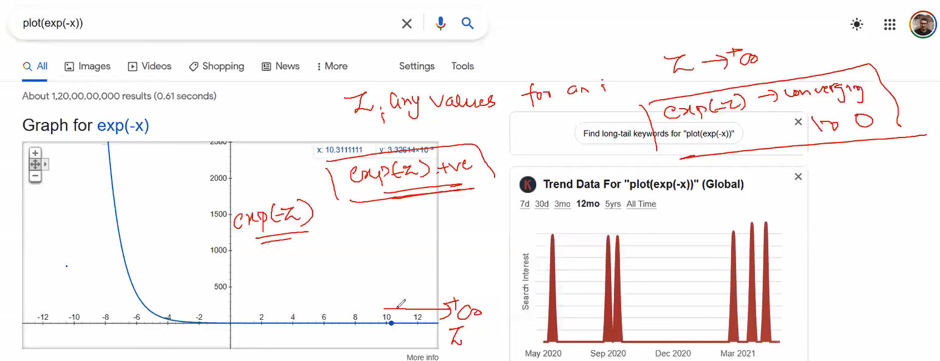

As z tends to be + ve exp(-z) approaches to 0.

We want all the points to be correctly classified, so the cost function>=0

Summarizing

Understanding over-fitting and under-fitting.

Regularization and analysing during over-fitting and under-fitting conditions

Implementation

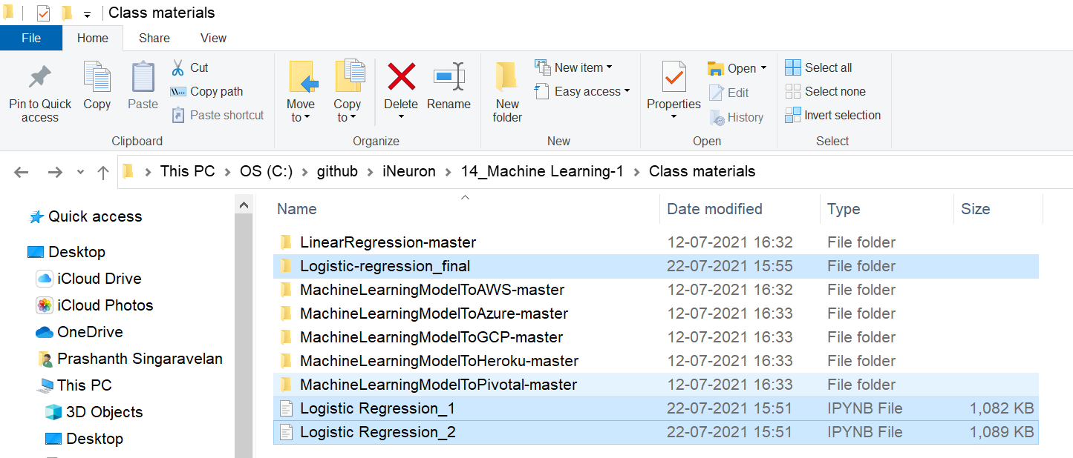

L2 Regularization Will penalize the un-wanted features by making the coefficients 0.

Confusion Matrix

Accuracy and Recall

Precision

True Positive Rate (Sensitivity)

False Positive Rate (1 – Specificity)

Dealing with imbalance data-sets

If we want to reduce FP, go with Precision.  
If we want to reduce FN, go with Recall.

Remember finally you are going to reduce FP and FN.

# **ROC and AUC curves**

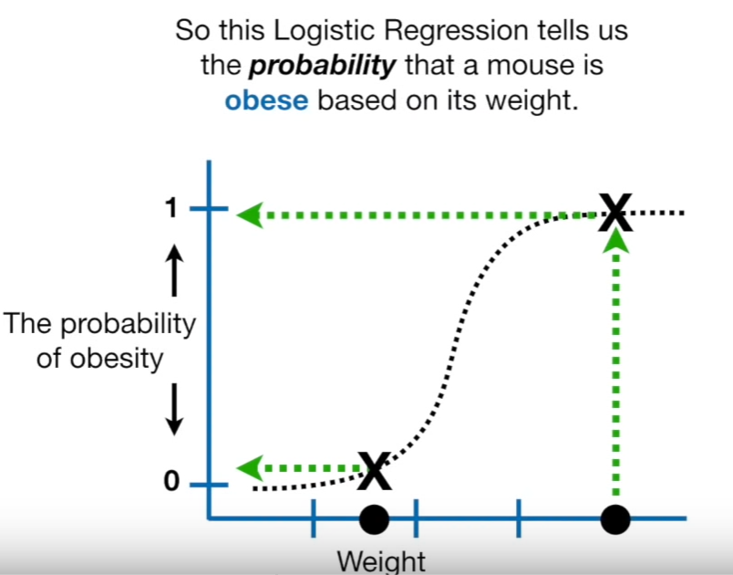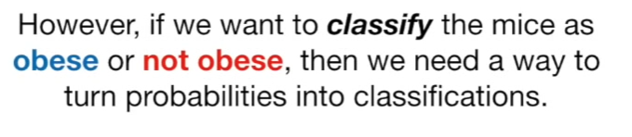  
By setting the threshold=0.5 we classified the sample into obese and not obese.

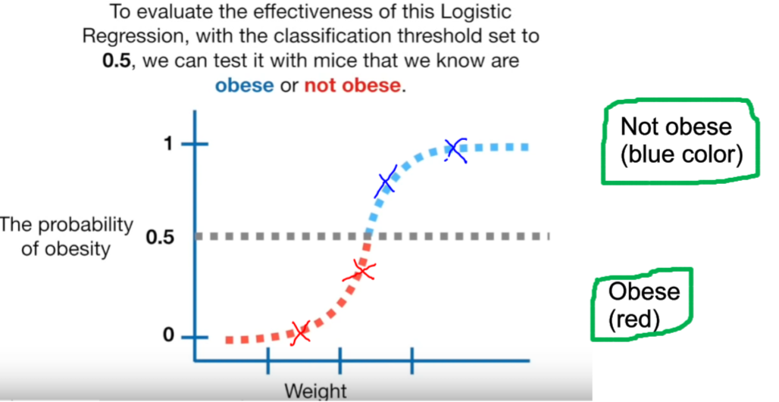

## **Considering the data**

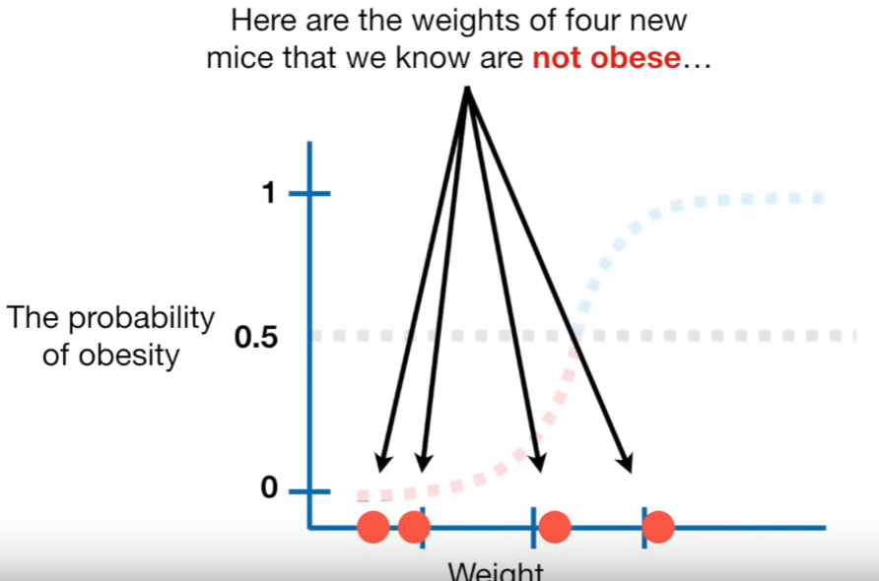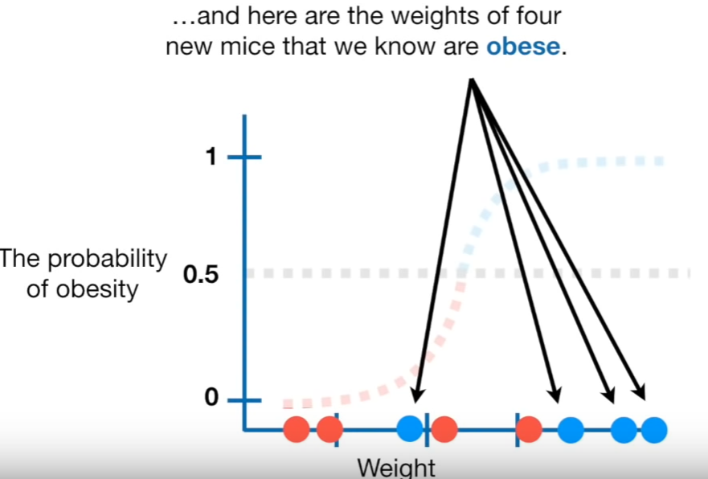

## **Observing via Confusion Matrix**

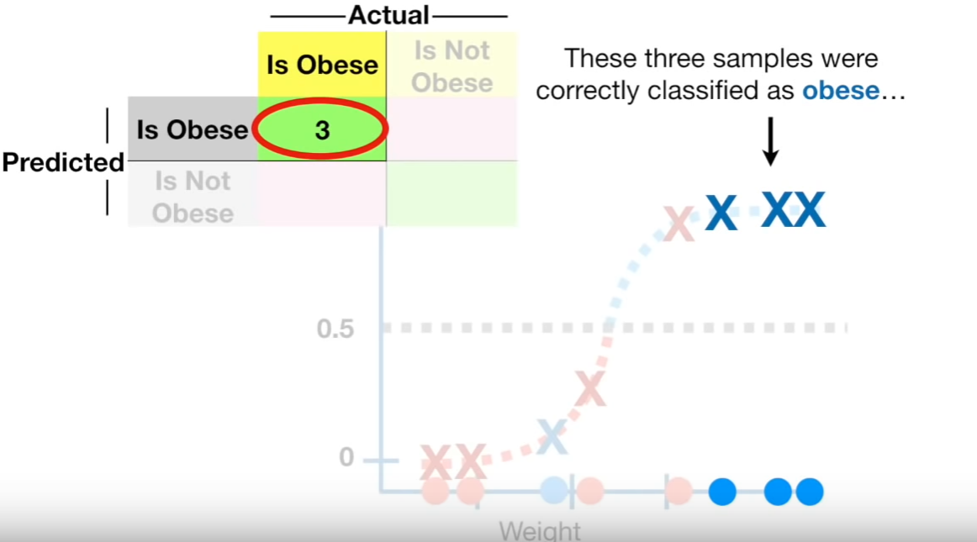  
Correctly classified as obese.

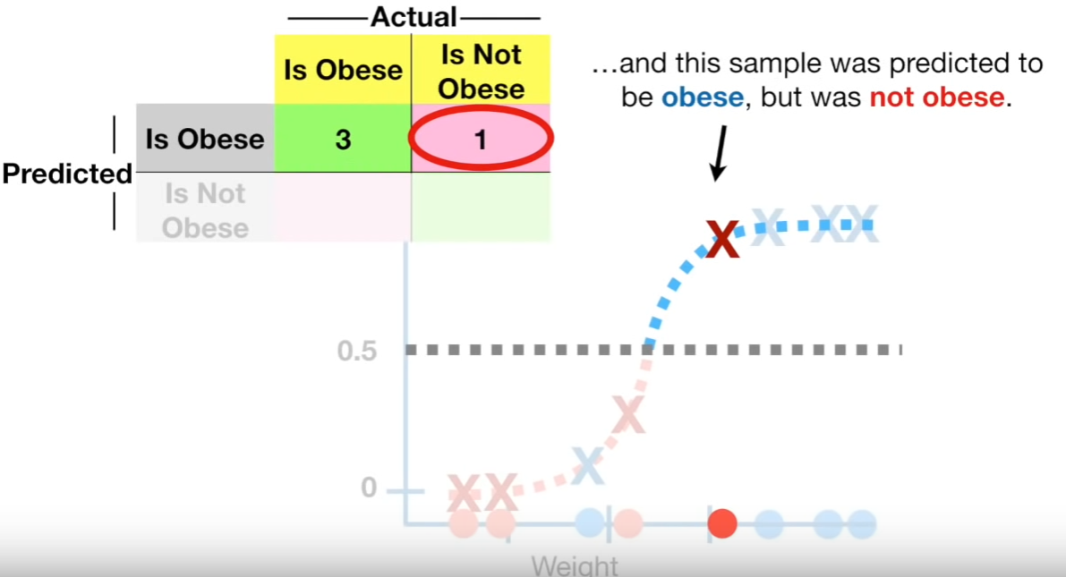  
Predicted 🡪Obese but actual 🡪 Not Obese

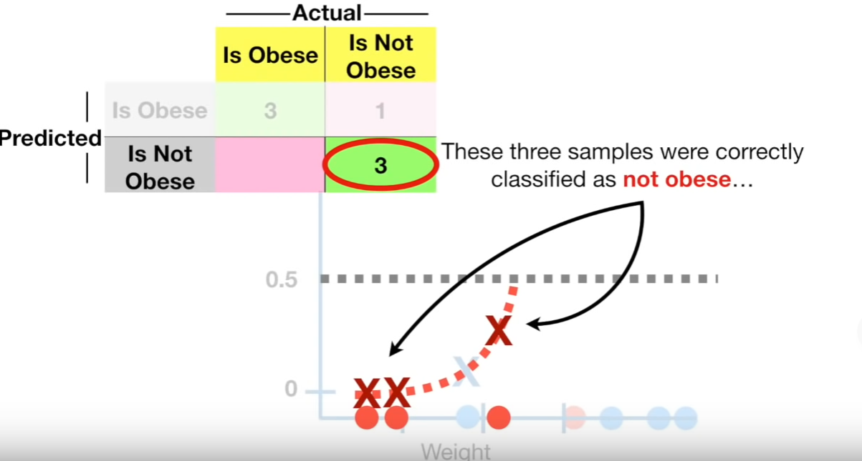  
Correctly classified as Not Obese.

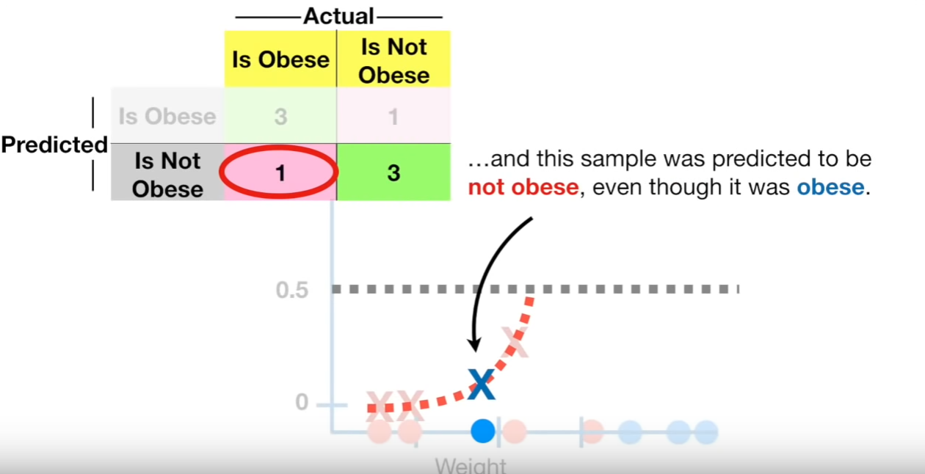  
Predicted 🡪Not obese but actual 🡪 Obese

Then we can calculate Sensitivity and Specificity.

## **Changing the threshold values**

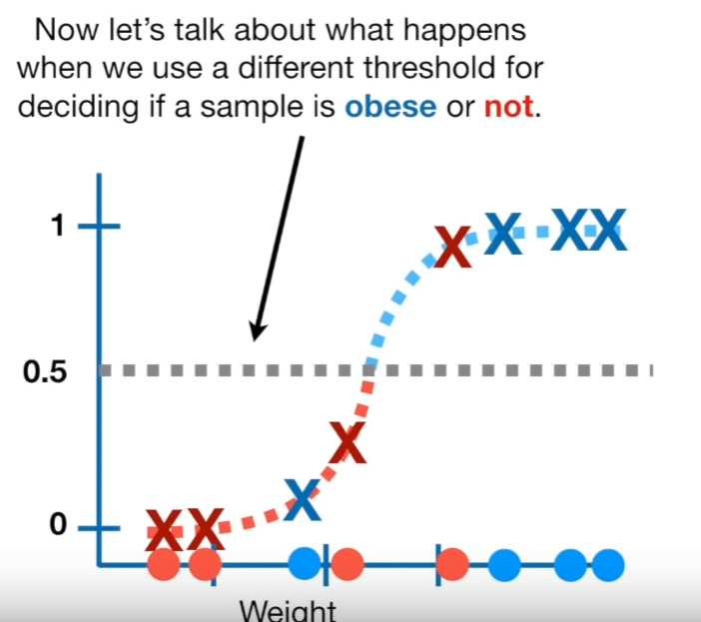

Not lowering and setting the threshold to 0.1  
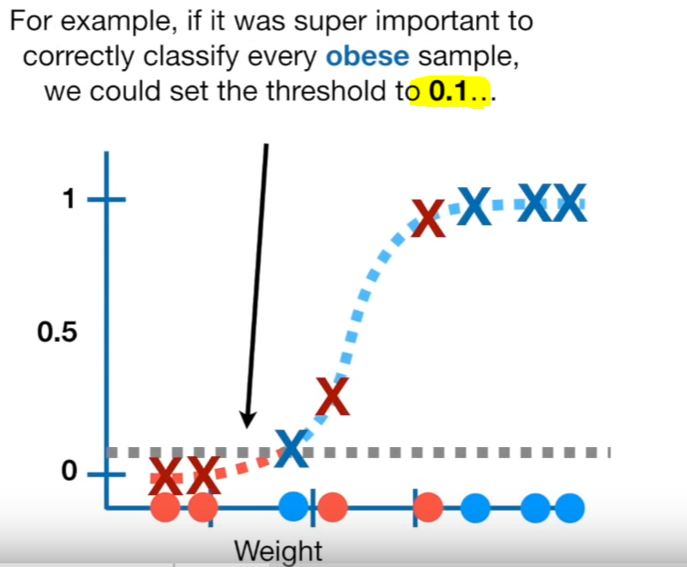  
Now the aim is to correctly classify the obese.

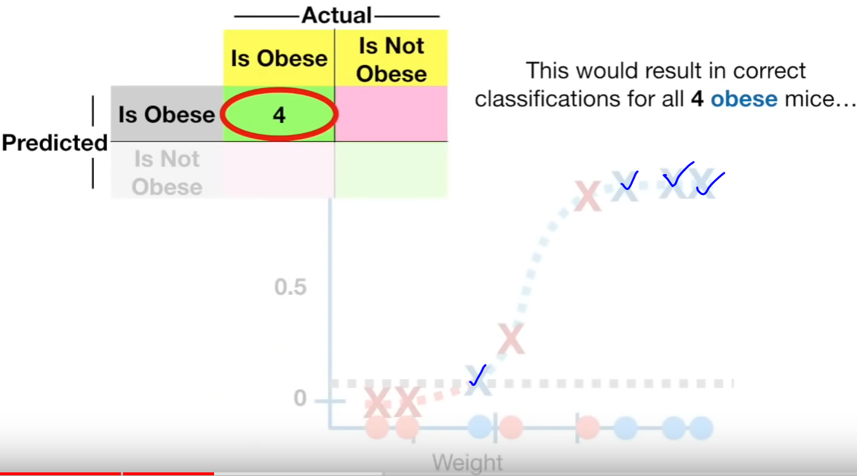

All 4 obese mices are correctly classified.

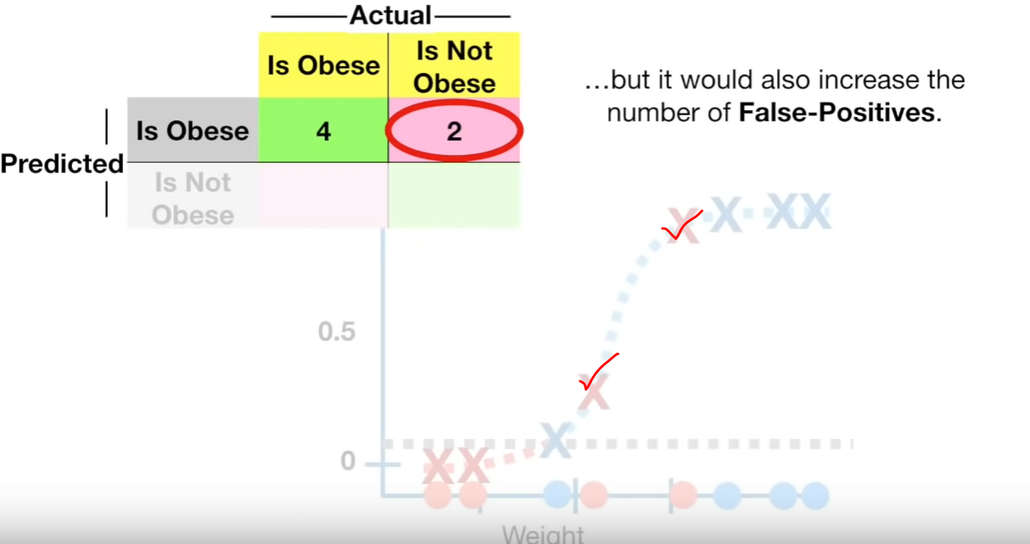

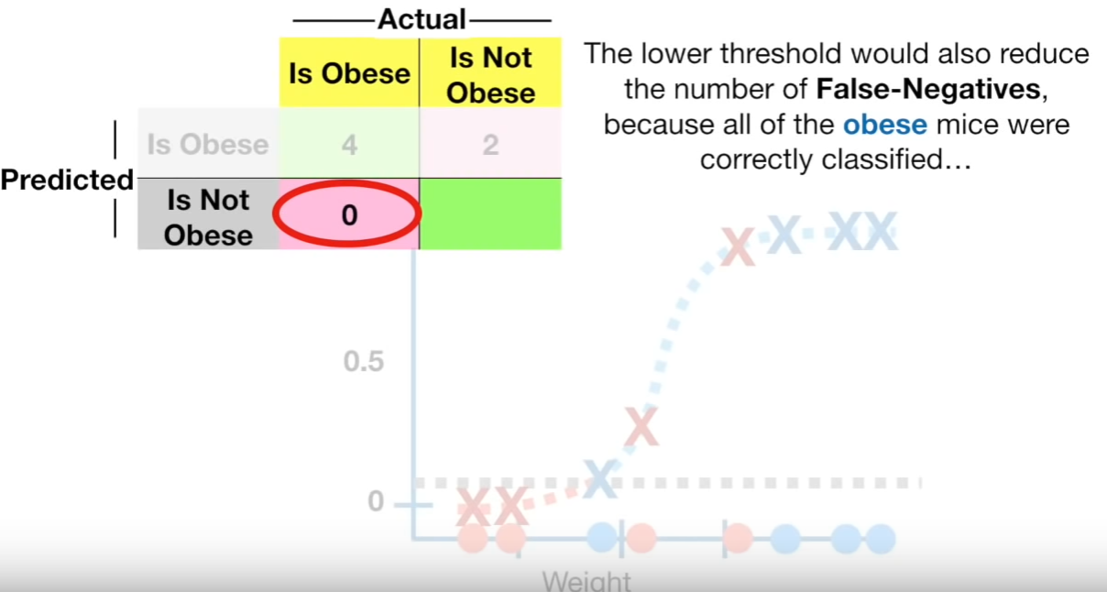

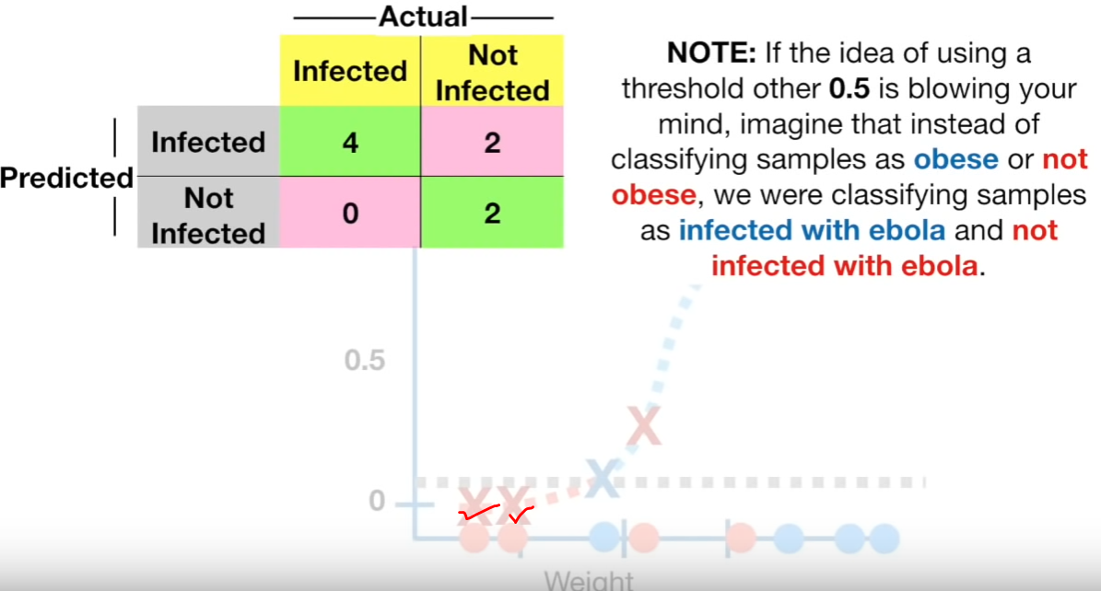

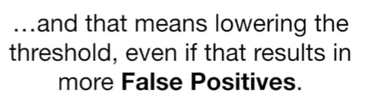  
Lowering the thresholds increases the false positive.  
Lowering the thresholds decreases the false negative.

Not increasing and setting the threshold to 0.9.

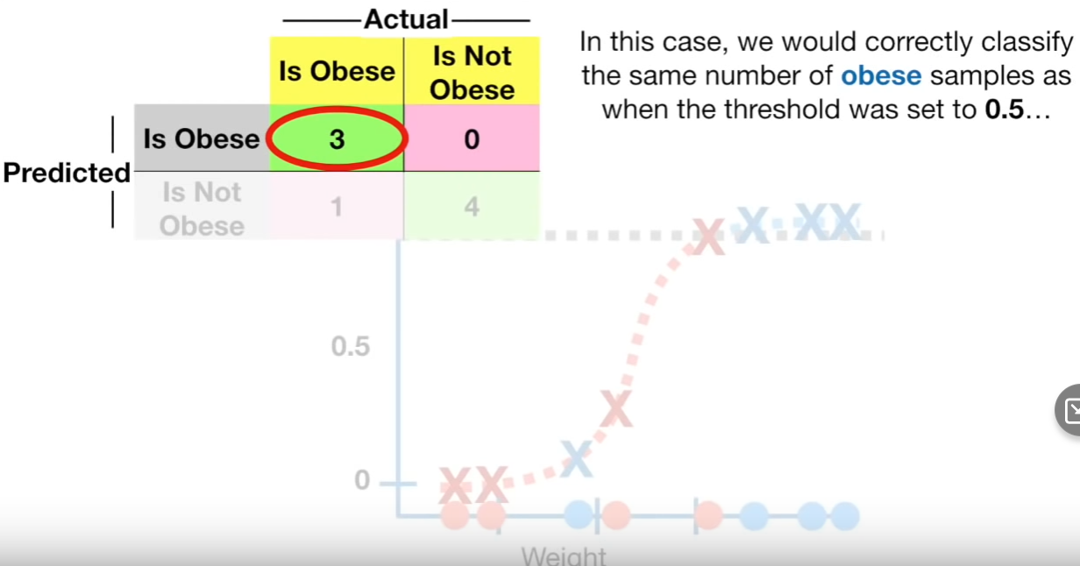

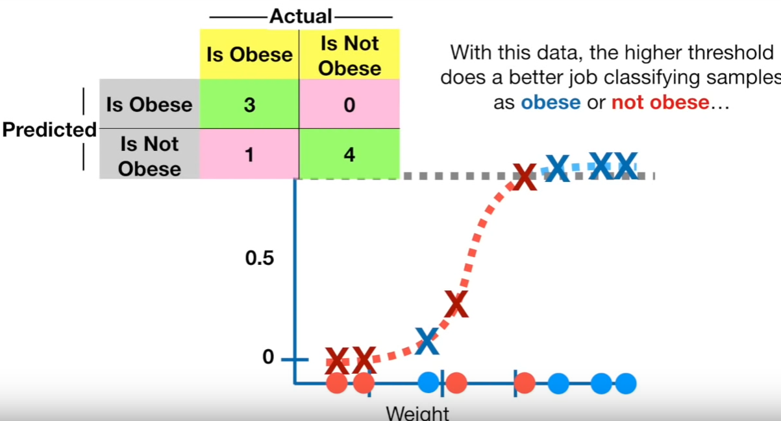

In this case, Higher threshold correctly classifies the samples.

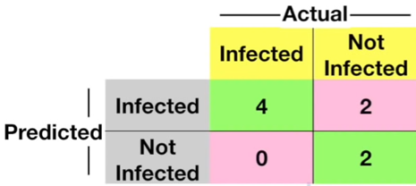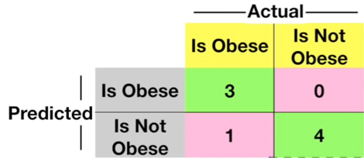

threshold=0.1 threshold = 0.9  
False positive = 2 False positive = 0  
False Negative = 0 False Negative = 1

## **How to determine which threshold is best for better classification???** threshold-1 🡪 1st Confusion Matrix threshold-2 🡪 2nd Confusion Matrix threshold-3 🡪 3rd Confusion Matrix threshold-4 🡪 4th Confusion Matrix

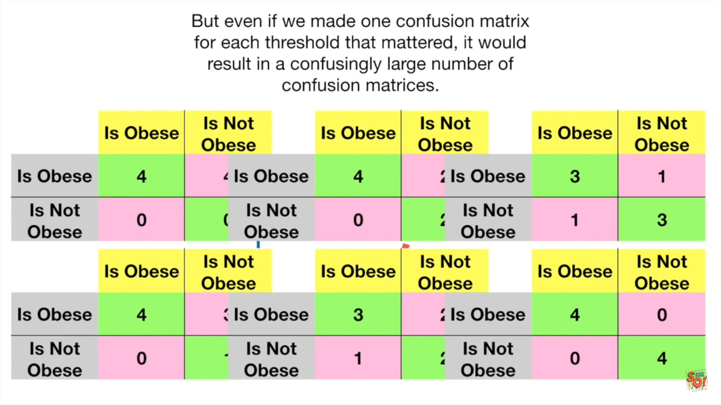**ROC Curve**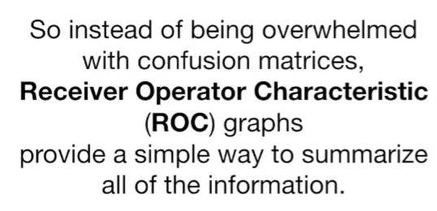

**Y-axis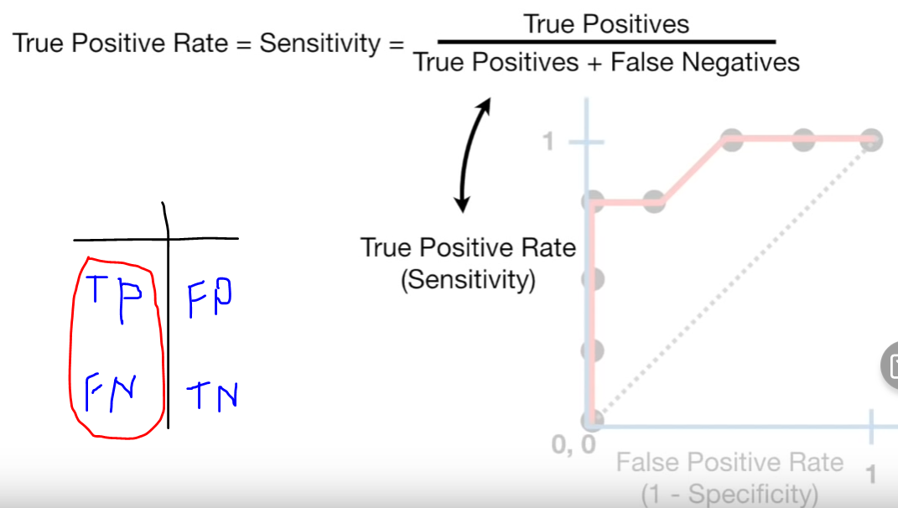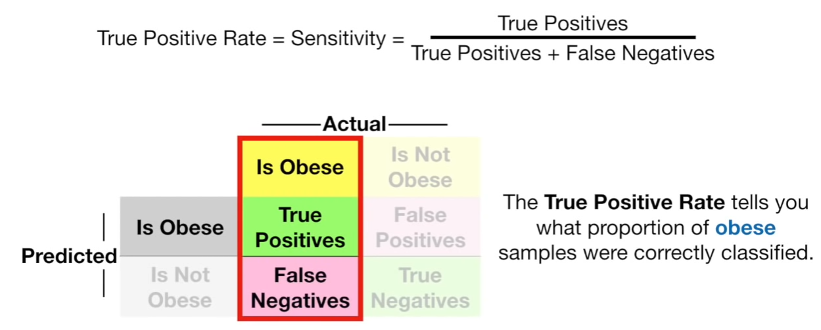 X-axis**  
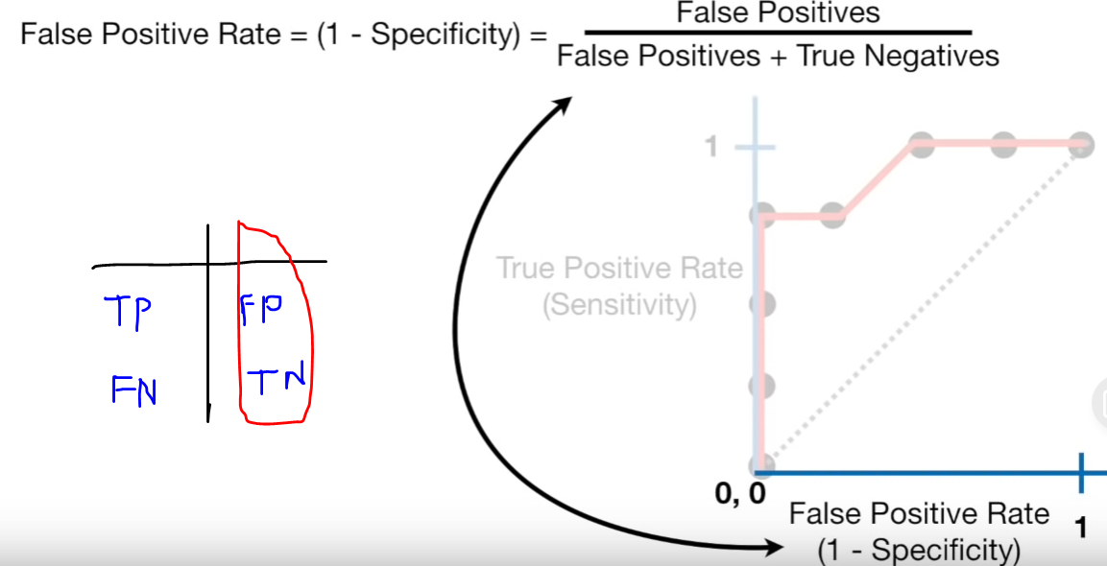

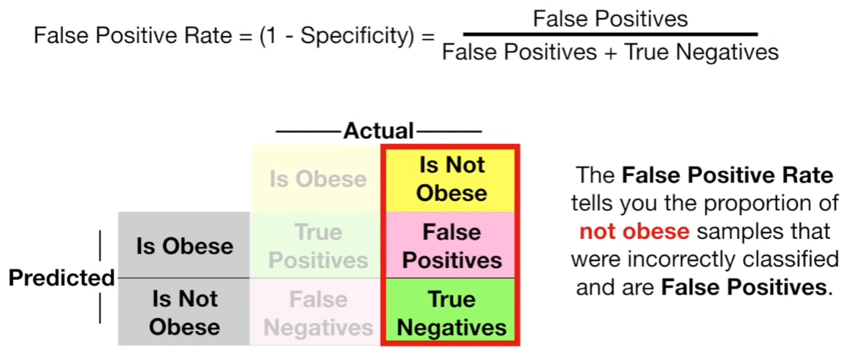

## **Checking with different values of threshold**

Now threshold = [x1]

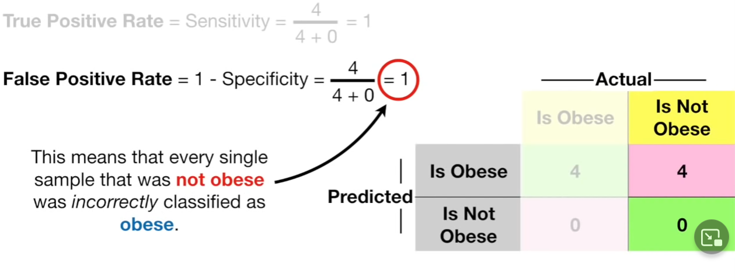

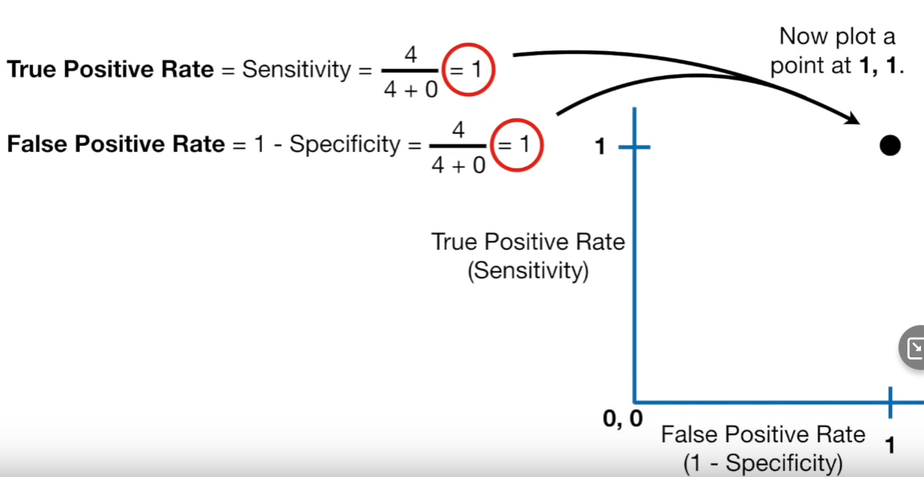

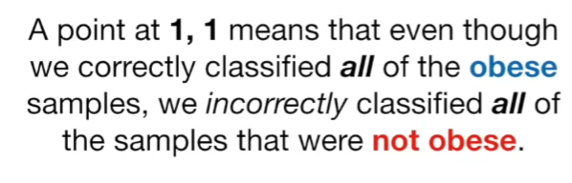Actual all obese 🡪 we predicted obese  
Actual all non-obese 🡪 we predicted obese

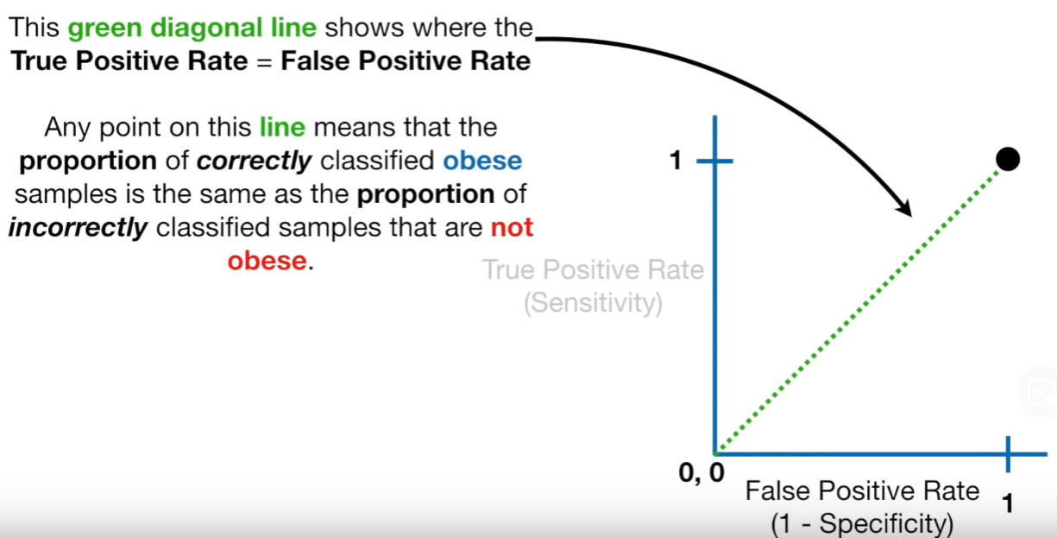

Now threshold = x2  
threshold = [x1,x2]

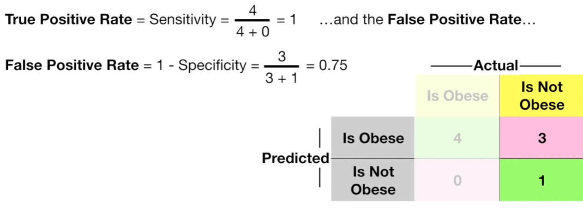

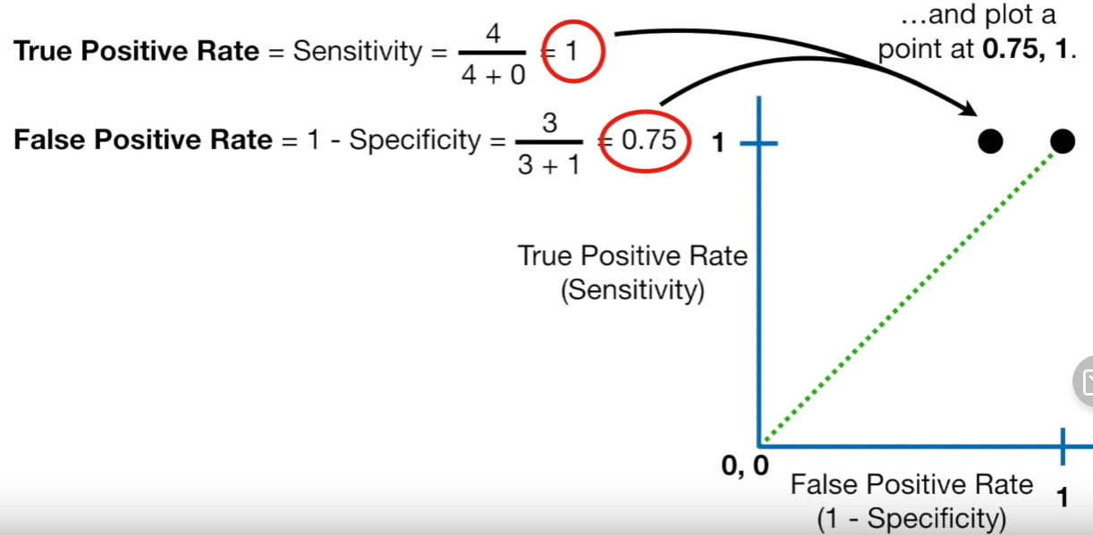

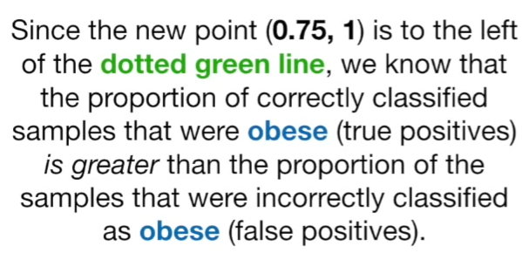  
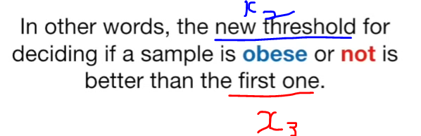

Now threshold = x3  
threshold = [x1,x2,x3]

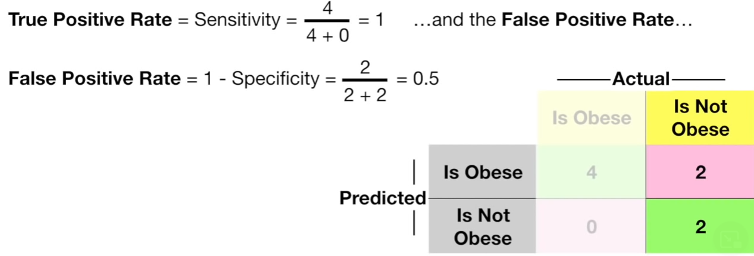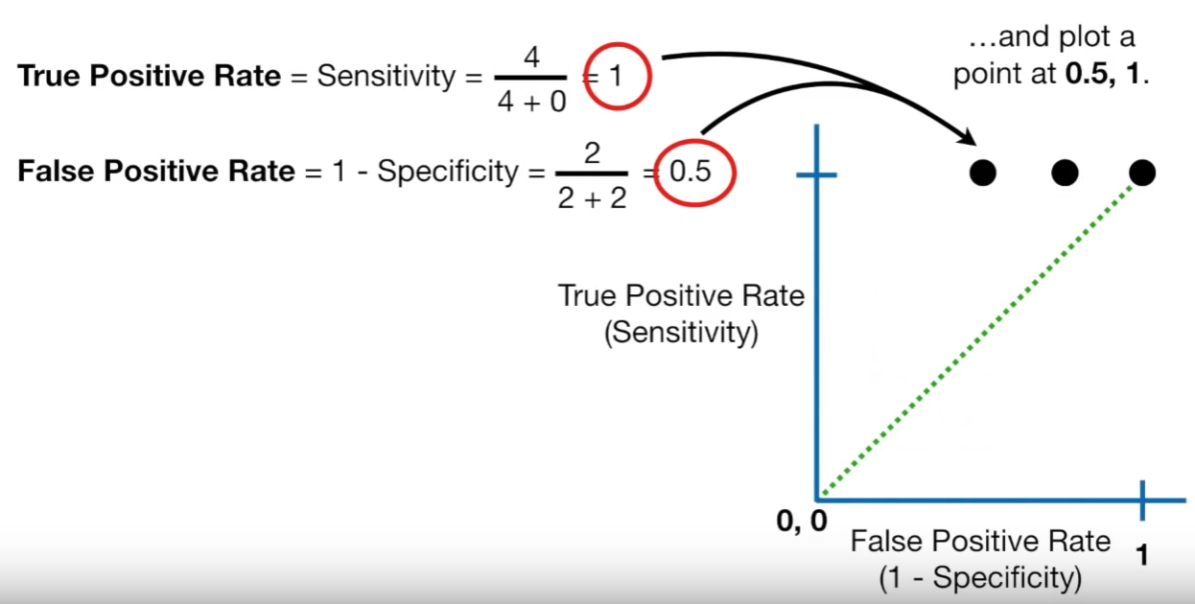

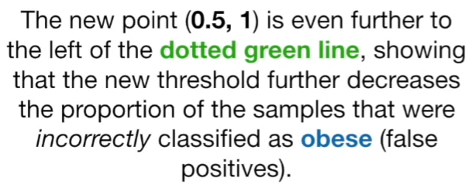

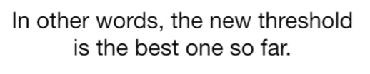

Now threshold = x4 (big increase from before)  
threshold = [x1,x2,x3,x4]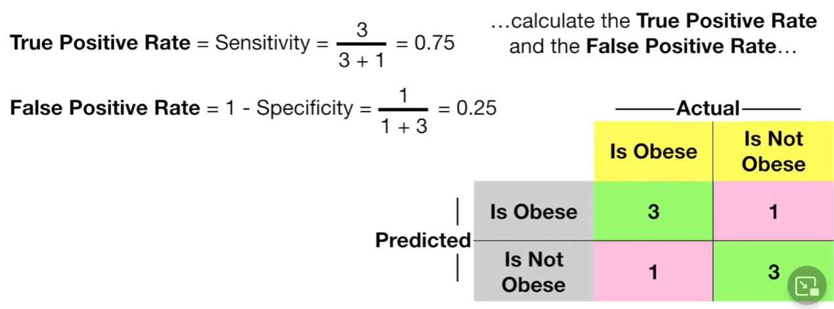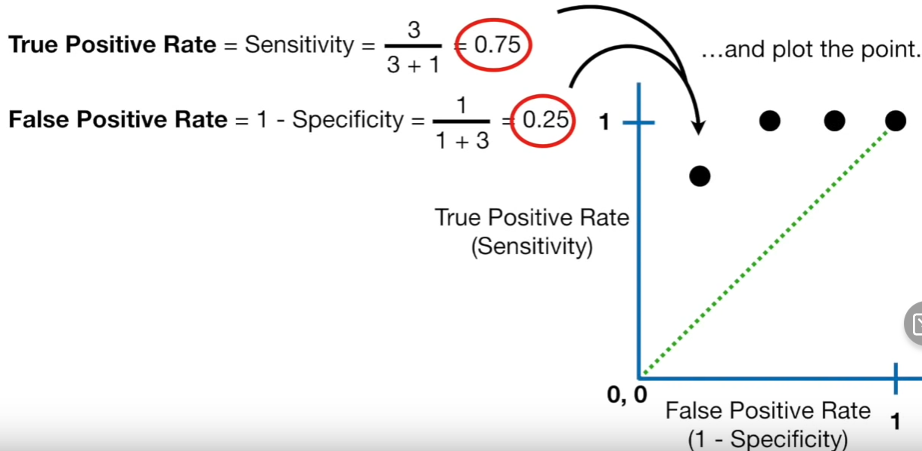

Now threshold = x5 (very big increase from before)  
threshold = [x1,x2,x3,x4,x5]

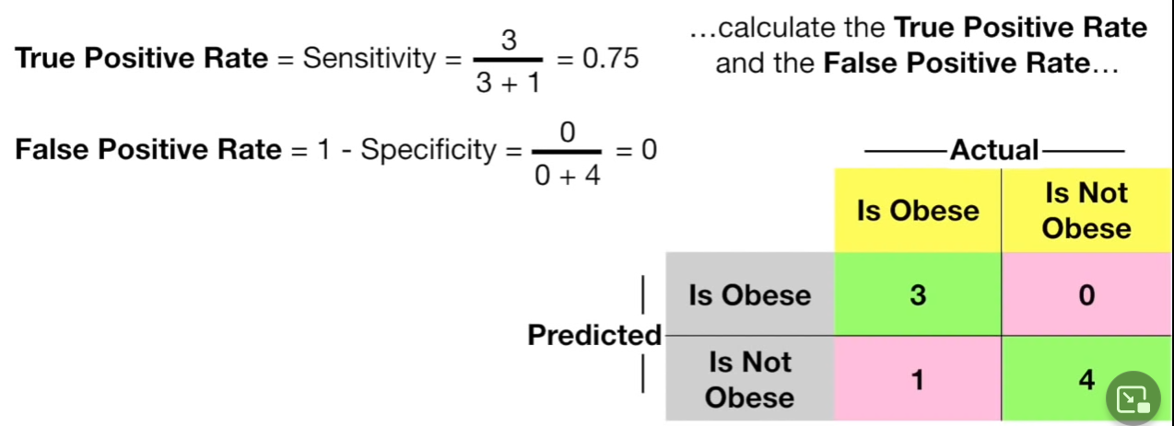

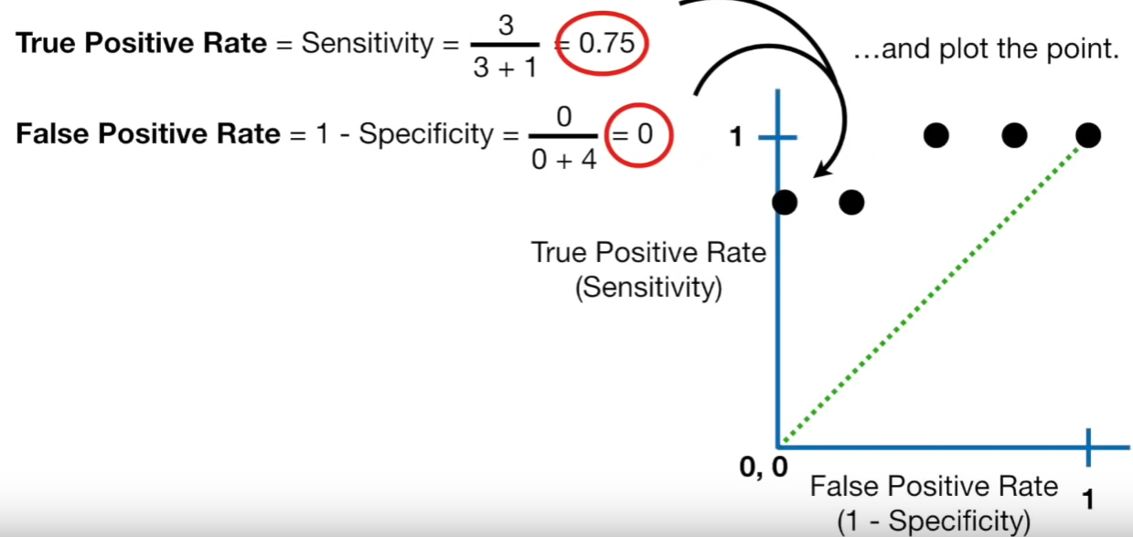

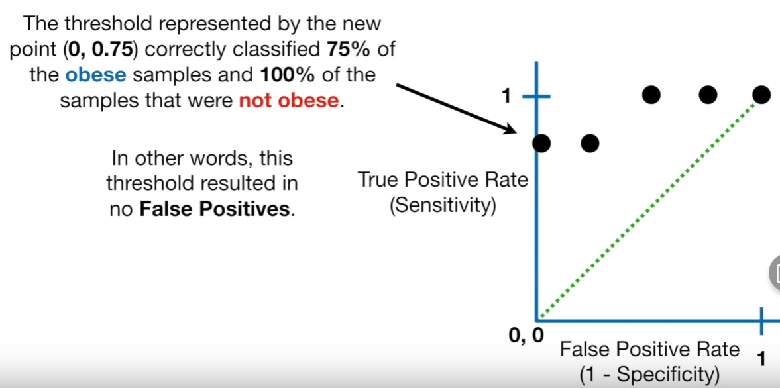

Now threshold = x6  
threshold = [x1,x2,x3,x4,x5,x6]

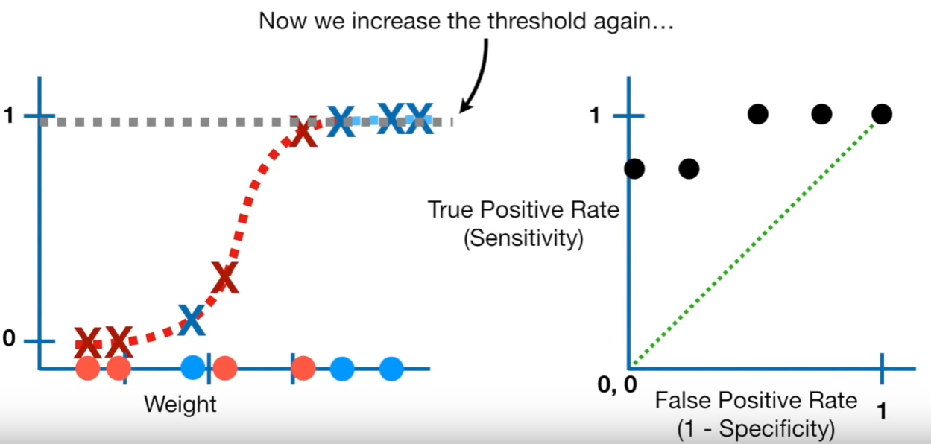  
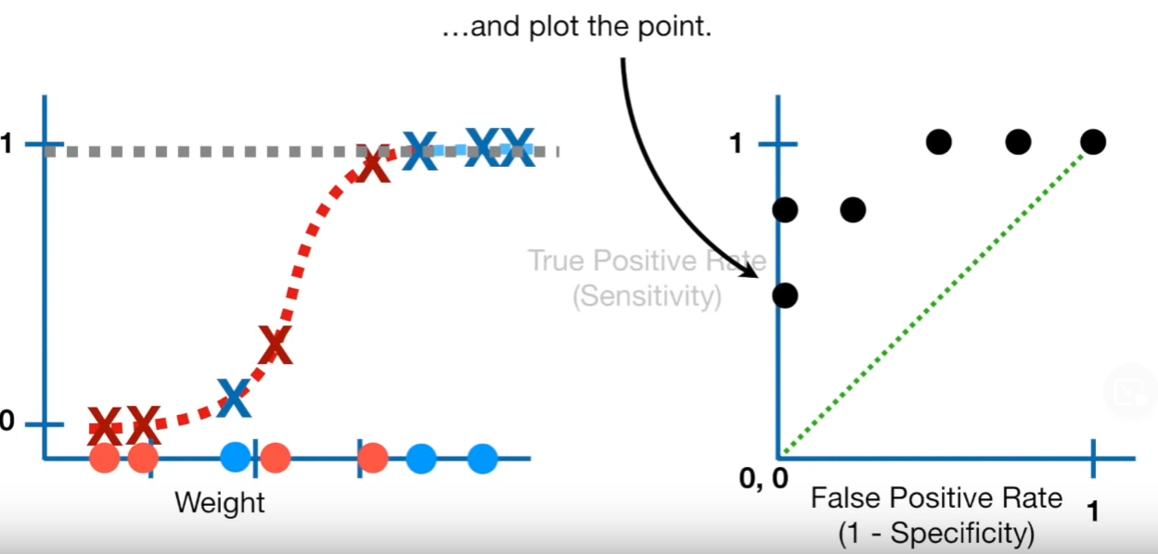

Now threshold = x7  
threshold = [x1,x2,x3,x4,x5,x6,x7]

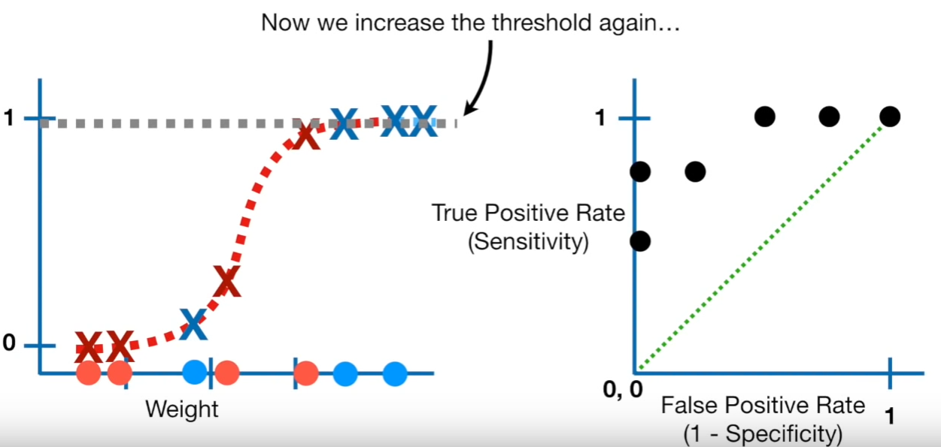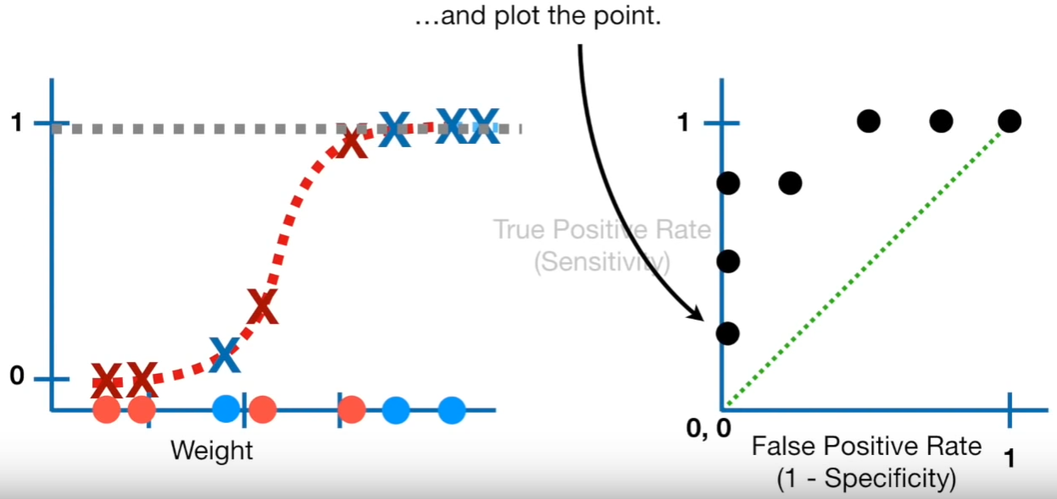

Now threshold = x8  
threshold = [x1,x2,x3,x4,x5,x6,x7,x8]

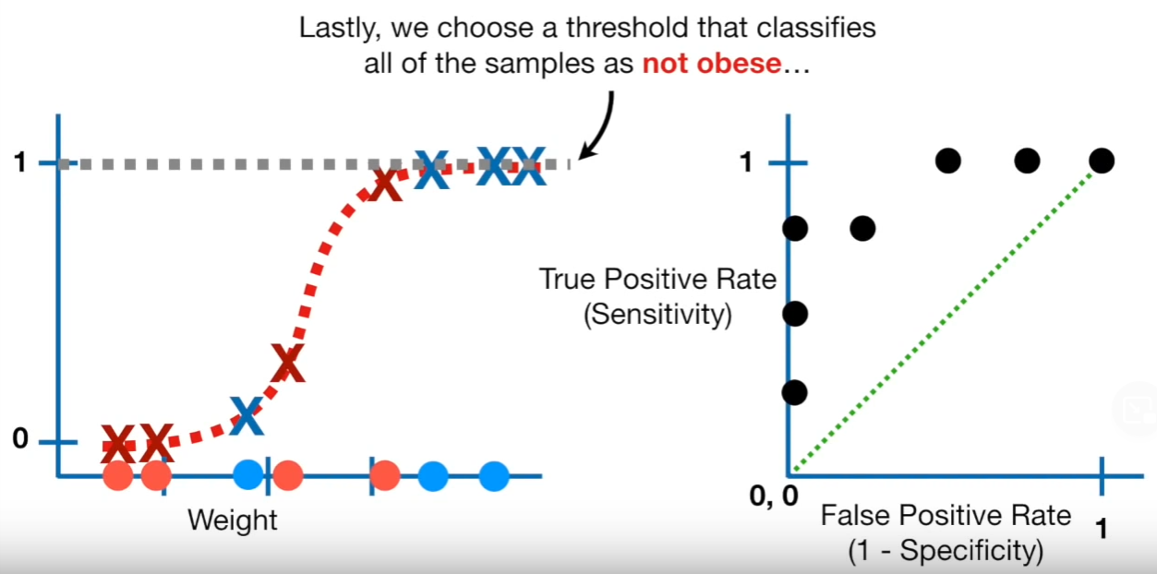

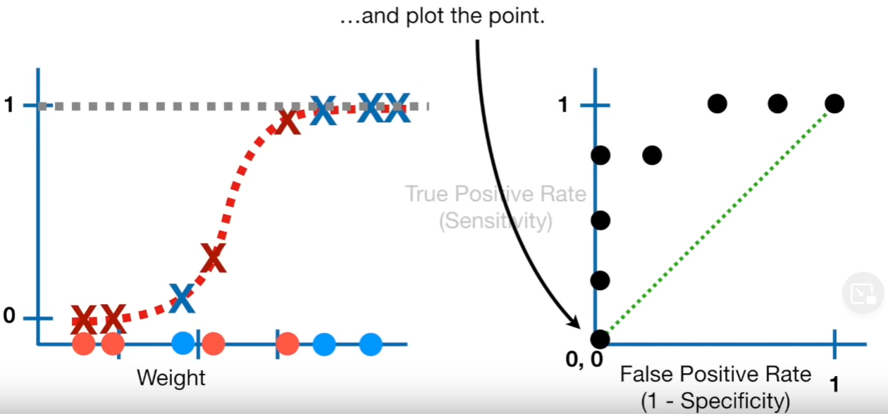

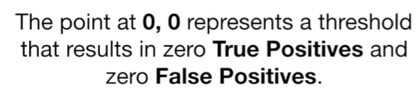

Connecting the dots

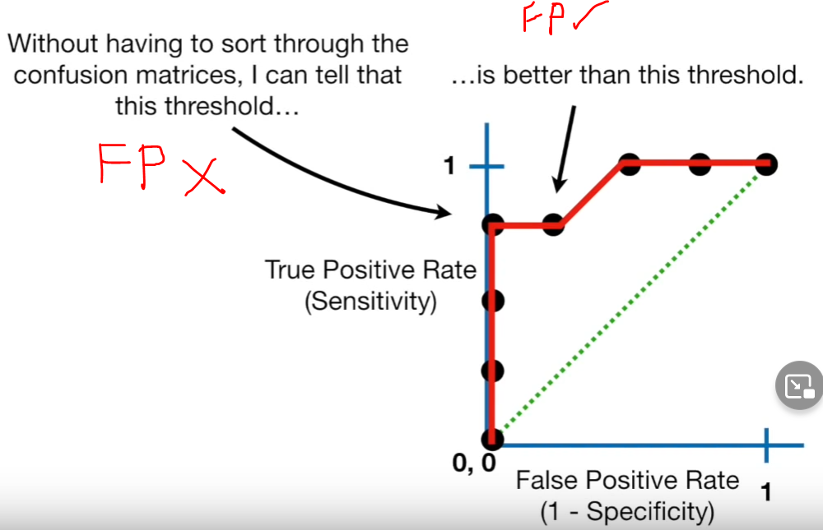

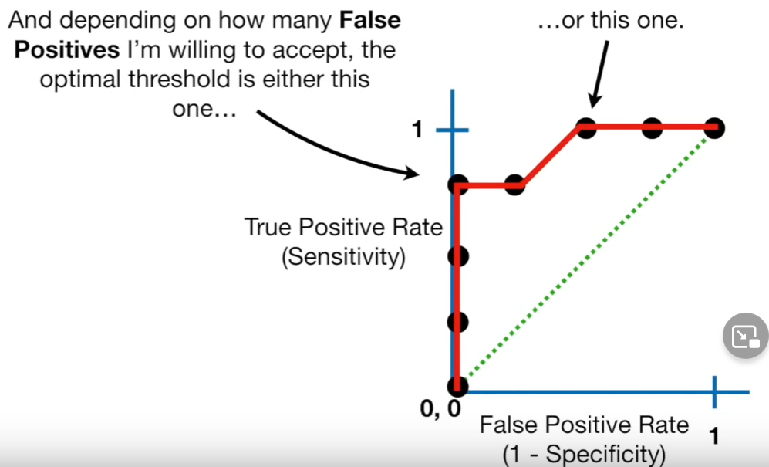

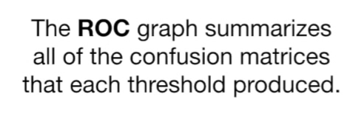

## **AUC(Area Under the Curve)**

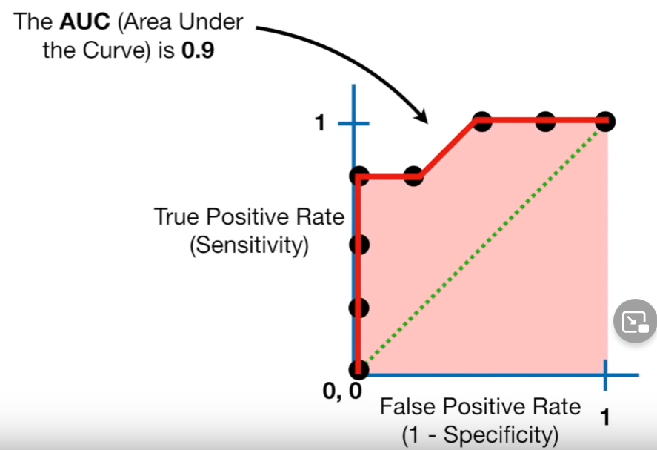

AUC curve will make it easier to compare with one ROC curve with other.

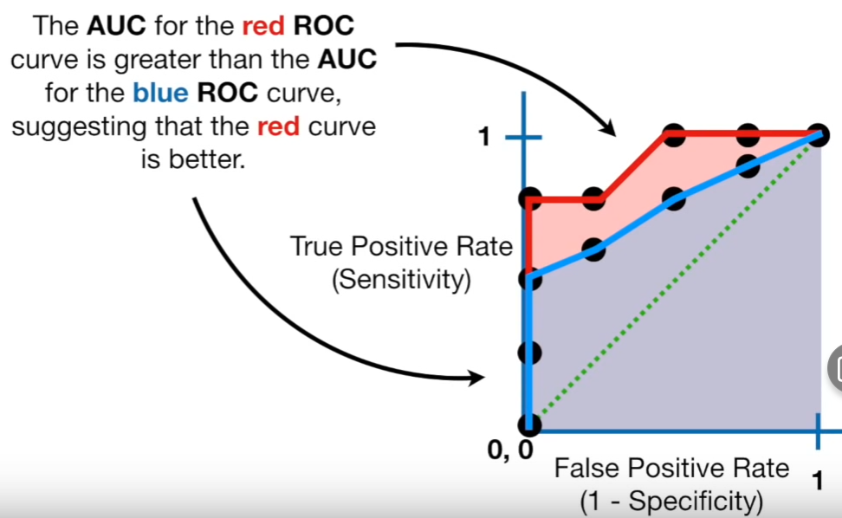

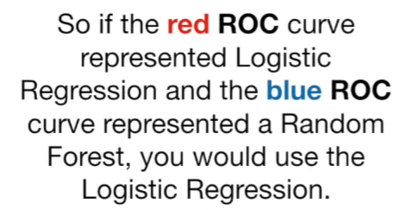

# **Db GridSearch CV and RandomizedSearch CV**

References  
<https://www.youtube.com/watch?v=tYZ6cpatw-w>

<https://www.youtube.com/watch?v=4jRBRDbJemM>

1. <https://www.youtube.com/watch?v=w4frwjt8uCo>
2. <https://towardsdatascience.com/understanding-the-roc-curve-and-auc-dd4f9a192ecb>
3. <https://stats.stackexchange.com/questions/123124/how-to-determine-the-optimal-threshold-for-a-classifier-and-generate-roc-curve>